
RAMAIAH
Institute of Technology
USN | 1 | M | S

(Autonomous Institute, Affiliated to VTU)
(Approved by AICTE, New Delhi & Govt. of Karnataka) Accredited by NBA & NAAC with ‘A’ Grade

EXAMINATIONS SEPTEMBER /OCTOBER 2020
SUPPLEMENTARY SEMESTER / GRADE IMPROVEMENT/ RE –REGISTERED CANDIDATES
Program | : | B.E :Electrical & Electronics Engineering | Semester | : | VI
Course Name | : | Power Systems - I | Max. Marks | : | 100
Course Code | : | EE61 | Duration | : | 3 Hrs

Instructions to the Candidates:
- Answer any one full question from each unit.
- Missing data may be assumed suitably.

 |  | UNIT- I
1. | a) | Discuss the major advantages of per unit system. | CO2 | (08)
 | b) | The single line diagram of an unloaded power system is shown in Fig.1(b). Reactances of the two sections of the transmission lines are shown. The generators and the transformers are rated as follows. Draw the impedance diagram with all reactances marked in pu. Choose a base of 50MVA, 13.8kV in the circuit of generator1.  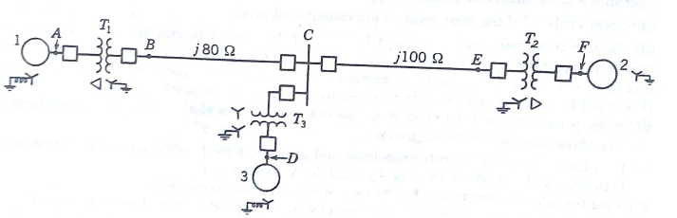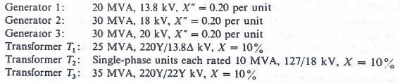  Fig1(b) | CO1 | (12)
2. | a) | Explain sub-transient, transient and steady state current in a synchronous machine. A synchronous generator and motor rated 30MVA, 13.2kV and both have sub-transient reactance of 20%. The line connecting them has a reactance of 10% on the base of the machine ratings. The motor is drawing 20MW at 0.8 pf leading. The terminal voltage of the motor is 12.8kV. When a symmetrical 3 phase fault occurs at the motor terminals at p, find the sub-transient current in generator, motor and at the fault point. The equivalent circuit is shown in Fig. 2(a). Choose generator ratings as the base.  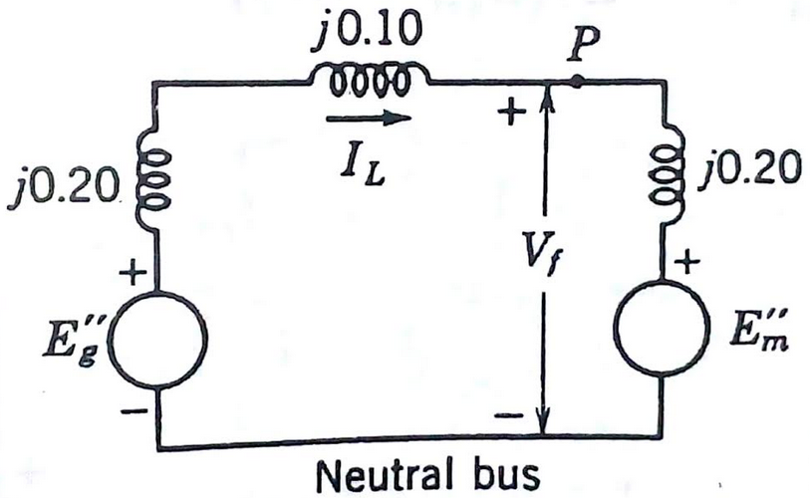  Fig.2 (a) | CO3 | (14)
 | b) | Explain the concept of complex power and the direction of power flow. | CO1 | (06)
 |  | UNIT– II
3. | a) | Using the concept of symmetrical components prove that a balanced three phase system of voltage phasor contains only positive sequence components. | CO4 | (08)
 | b) | Labelling of lines connected to a three phase star-delta transformer is shown in Fig.4 (a). Draw the corresponding wiring diagram and voltage components. Explain the phase shift of symmetrical components. Assume star side is on the high tension side.  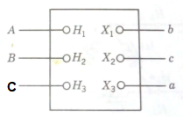  Fig.4(a) | CO3 | (12)
4. | a) | Discuss the phase shifts of sequence components of voltages in the primary and secondary windings of a star-delta transformer with the help of phasor diagrams. | CO1 | (10)
 | b) | The currents flowing in the lines towards a balanced load connected in delta are I_{a} =100∟0⁰, I_{b}=141.4∟225⁰, I_{c} =100∟90⁰ A. Start by drawing phasor diagrams of of the positive and negative sequence line and phase currents and find the symmetrical components of the given line currents. Find I_{ab} in Amperes from the symmetrical components of the given line currents. | CO4 | (10)
 |  | UNIT- III
5. | a) | Obtain the sequence networks of an unloaded three phase star connected generator grounded through a reactor. | CO4 | (08)
 | b) | Across a star connected symmetrical impedance load of 10Ω in each phase and a neutral impedance of 3.33Ω, an unbalanced 3phase supply with V_{a}=220∟0⁰, V_{b}=200∟110⁰, and V_{c}=180∟-110⁰ is applied. Determine the line currents using symmetrical components. | CO4 | (12)
6. | a) | Obtain the zero sequence equivalent circuits of three phase transformer banks shown in Fig.6(a). Justify the connection diagram.  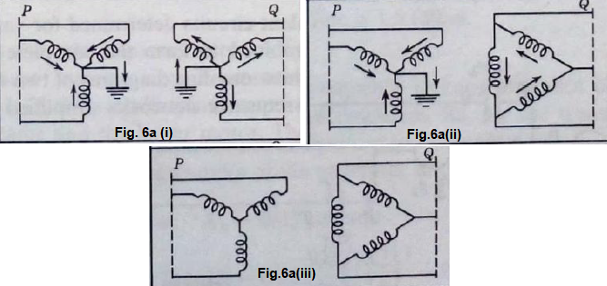  Fig.6(a) | CO4 | (12)
 | b) | Explain the concept of sequence impedances and sequence networks. | CO4 | (08)
 |  | UNIT- IV
7. | a) | Draw and explain the interconnection of sequence networks in case of i) line to ground fault ii) double line to ground fault. | CO4 | (12)
 | b) | A salient pole generator rated 20MVA, 13.8kV, with X₁= 0.25pu, X₂= 0.35pu and X₀=0.1pu. The neutral of the generator is solidly grounded. Determine the sub-transient current in the generator and the line to line voltages for sub-transient condition when an L-G fault occurs at the generator terminal with the generator operating at rated voltage. Neglect resistance. | CO4 | (08)
8. | a) | Explain unsymmetrical faults on power systems. | CO4 | (08)
 | b) | Derive the expression for the fault current in case of an L-G fault on an unloaded generator. Also draw the interconnection network. | CO4 | (12)
 |  | UNIT- V
9. |  | Write short notes on: i) steady state and transient stability ii) importance of power angle curve iii) advantages of equal area criterion iv) critical clearing angle. | CO5 | (20)
10. | a) | Explain:  i) power angle equation ii) concept of equal area criterion of stability. | CO5 | (12)
 | b) | Explain the factors affecting the transient stability. | CO5 | (08)

****************

